
36. Write an HTML program to add a background-image property using URL and style tag using external type of CSS.

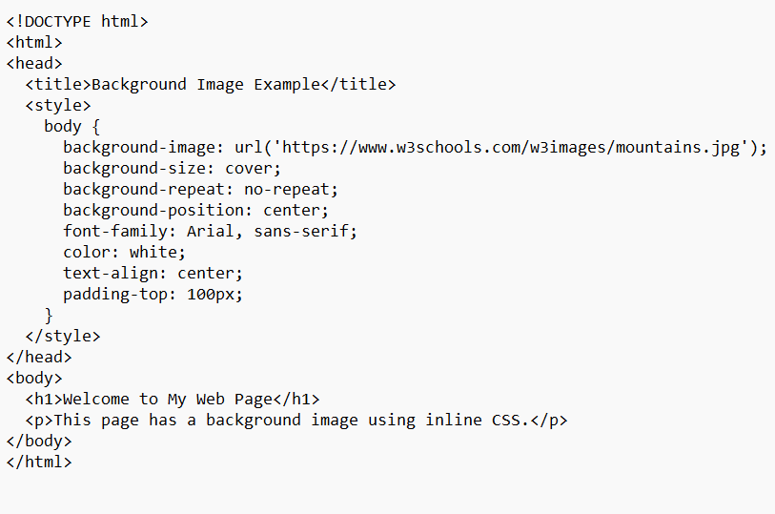

output

